**DAY 20 ALPHA DIVERSITY**

* Oberved

kruskal.test(Observed ~ Group, data=adiv20)

Kruskal-Wallis rank sum test

data: Observed by Group

Kruskal-Wallis chi-squared = 7.6379, df = 2, p-value =0.02195

* Shannon

kruskal.test(Shannon ~ Group, data = adiv20)

Kruskal-Wallis rank sum test

data: Shannon by Group

Kruskal-Wallis chi-squared = 7.215, df = 2, p-value =0.02712

* Pielou

> kruskal.test(Pielou ~ Group, data = adiv20)

Kruskal-Wallis rank sum test

data: Pielou by Group

Kruskal-Wallis chi-squared = 3.02, df = 2, p-value = 0.2209

* Dunntest Shannon

Dunn (1964) Kruskal-Wallis multiple comparison

p-values adjusted with the Bonferroni method.

Comparison Z P.unadj P.adj

1 Acetic - Citric -2.0152543 0.04387801 0.1316340

2 Acetic - Nothing 0.5303301 0.59588309 1.0000000

3 Citric - Nothing 2.5455844 0.01090950 0.0327285

* Dunntest observed

dunnTest(Observed ~ Group,

+ data = adiv20,

+ method= "bonferroni")

Dunn (1964) Kruskal-Wallis multiple comparison

p-values adjusted with the Bonferroni method.

Comparison Z P.unadj P.adj

1 Acetic - Citric -2.0351453 0.041836254 0.12550876

2 Acetic - Nothing 0.6016951 0.547377088 1.00000000

3 Citric - Nothing 2.6368405 0.008368218 0.02510465

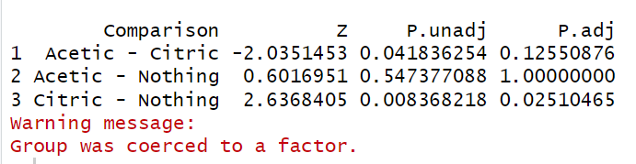

**DAY 28 WATER ALPHA DIVERSITY**

* Observed

Kruskal.test(Observed ~ Group, data=adiv28w)

Kruskal-Wallis rank sum test

data: Observed by Group

Kruskal-Wallis chi-squared = 2.6841, df = 2, p-value =0.2613

* Shannon

> kruskal.test(Shannon ~ Group, data = adiv28w)

Kruskal-Wallis rank sum test

data: Shannon by Group

Kruskal-Wallis chi-squared = 2.6875, df = 2, p-value =0.2609

* Pielou

> kruskal.test(Pielou ~ Group, data = adiv28w)

Kruskal-Wallis rank sum test

data: Pielou by Group

Kruskal-Wallis chi-squared = 2.2383, df = 2, p-value =0.3266

**DAY 28 LITTER ALHPA DIVERSITY**

* Observed

kruskal.test(Observed ~ Group, data=adiv28L)

Kruskal-Wallis rank sum test

data: Observed by Group

Kruskal-Wallis chi-squared = 3.3146, df = 2, p-value =0.1906

* Shannon

> kruskal.test(Shannon ~ Group, data = adiv28L)

Kruskal-Wallis rank sum test

data: Shannon by Group

Kruskal-Wallis chi-squared = 1.9735, df = 2, p-value =0.3728

* Pielou

> kruskal.test(Pielou ~ Group, data = adiv28L)

Kruskal-Wallis rank sum test

data: Pielou by Group

Kruskal-Wallis chi-squared = 0.68659, df = 2, p-value =0.7094